Note:

Every Collection class by default implements “Serializable” & “Cloneable” interfaces.(If an object is serializable then it can be streamed via network)

Serialization: Conversion of object to byte stream, Vice versa is deserialozation.

Marker interface(An interface with ZERO method, but helps in signalling JVM to perform some additional magic)

Collections

Defines several classes and interfaces to represent group of individual objects as a single entity.

It defines most common methods like add, remove, contains, isEmpty which are applicable for any collection object.

pros:

-----------------

We can have heterogeneous(diff) type elements.

For every Collection Readymade methods are available

-> Because of Underlying Datastructures

-> Every Collection(ArrayList/hashset/tree....) is implemented by List,Set,...Interfaces

Can grow memory dynamically.

Cons:

------

can hold only Object types but not primitives.

Performance

Every Collection has default size limit.

If we need to add new element to ArrayList & whenever default limit is crossed

A new ArrayList gets created with all elements getting copied to this list and the extra memory.

Collection vs Collections:

--------------------------

Collections is a Utility class which provides sorting, searching, etc..,

List :

-------

duplicates allowed

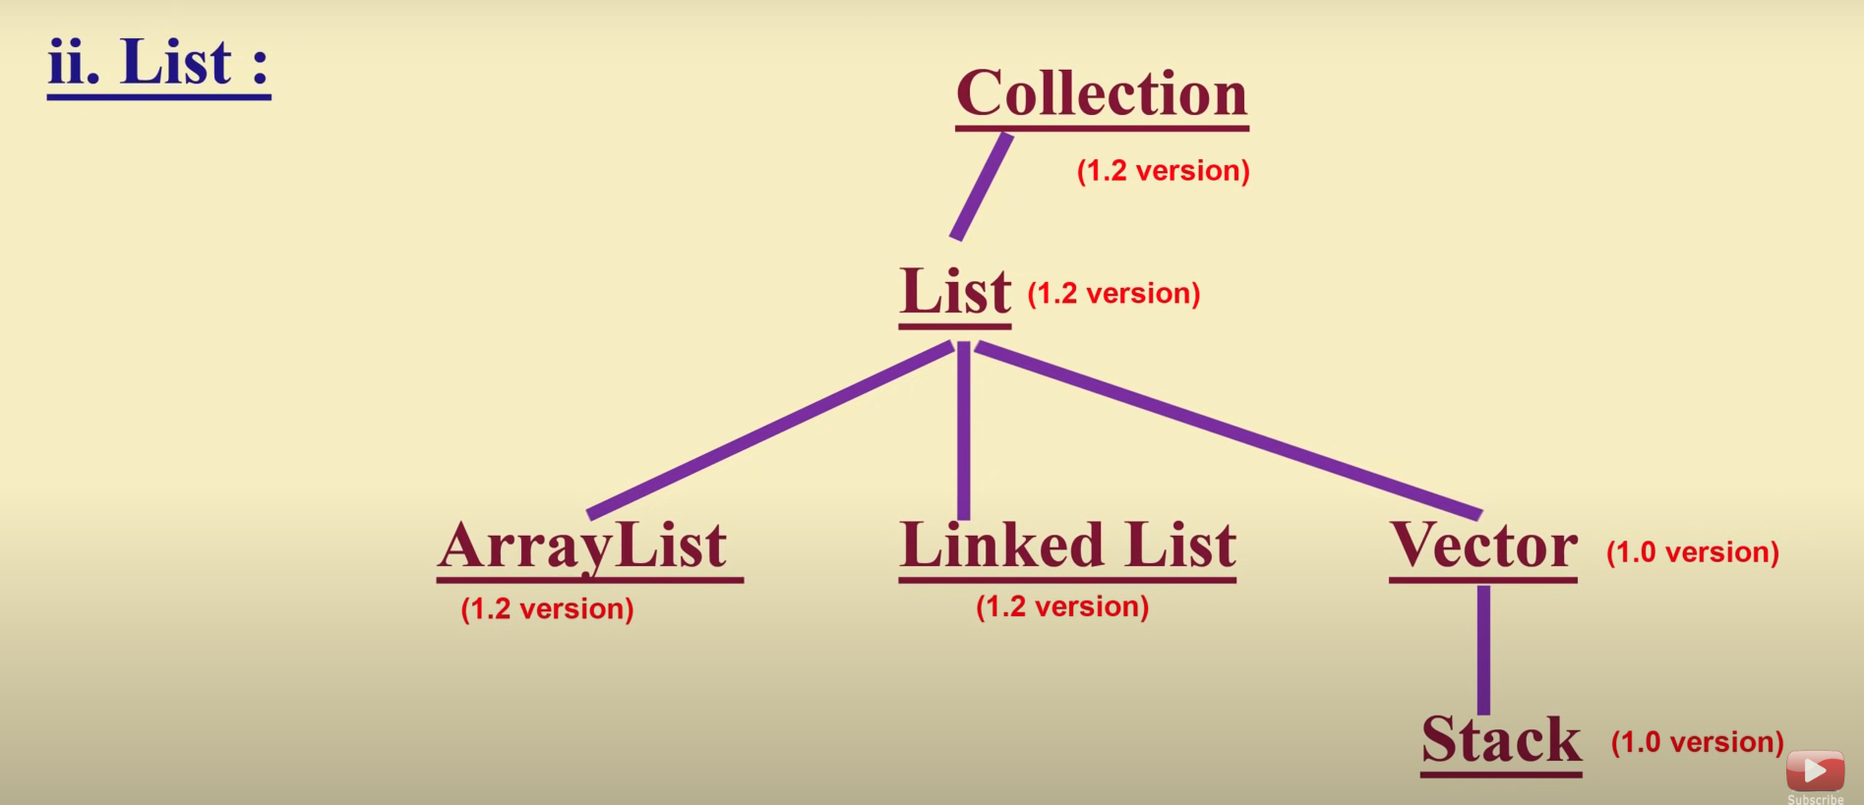

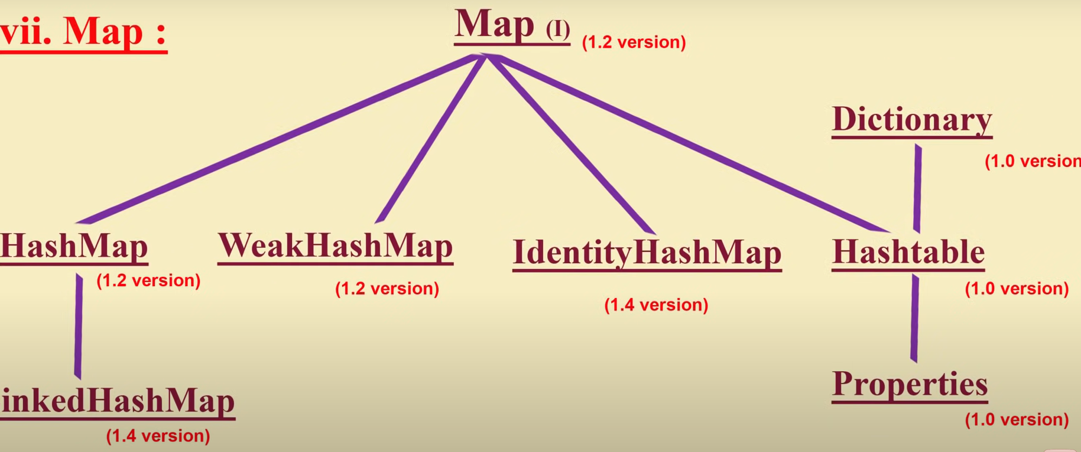

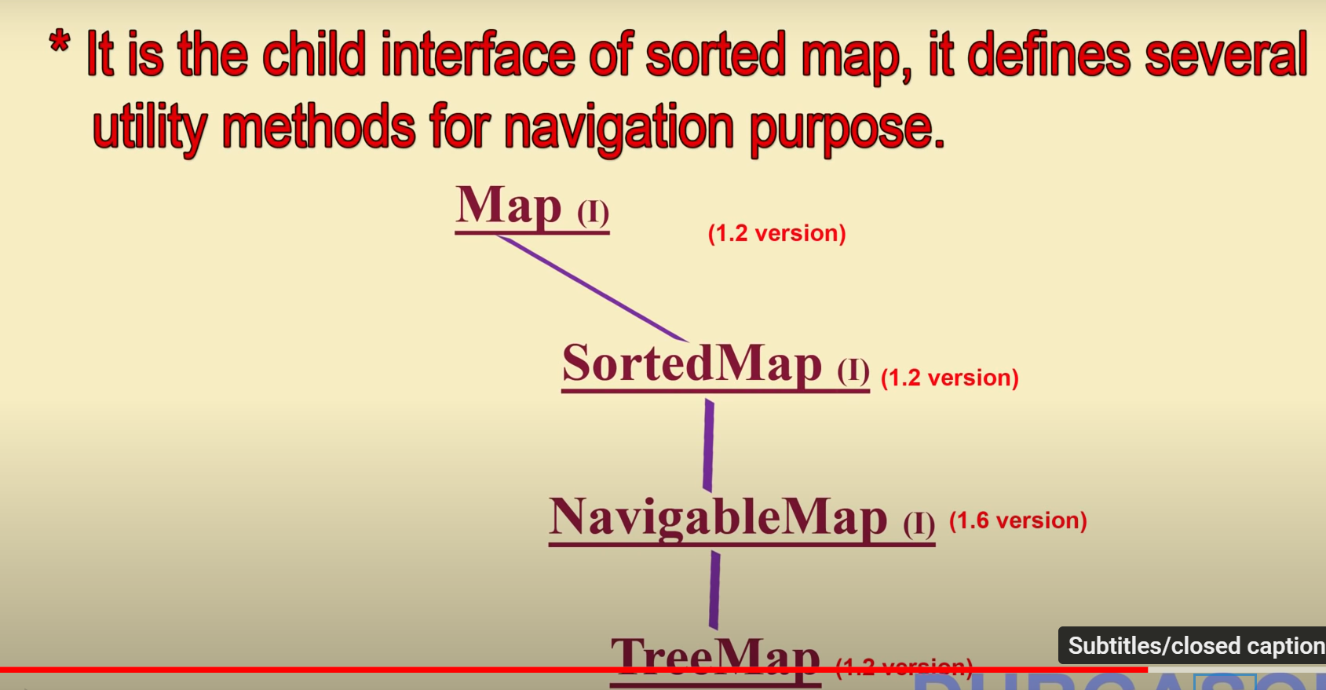

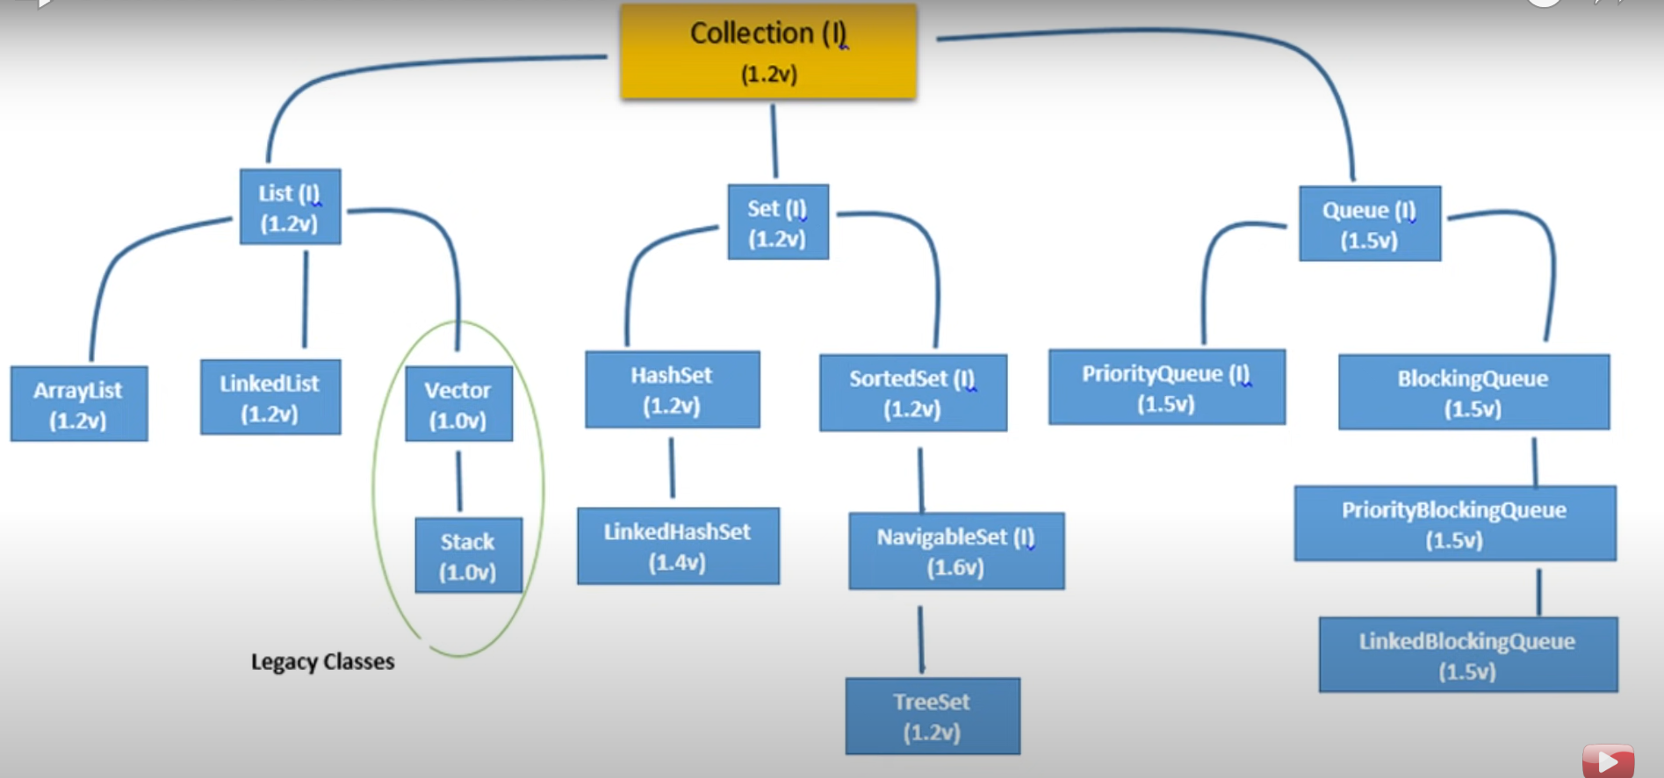

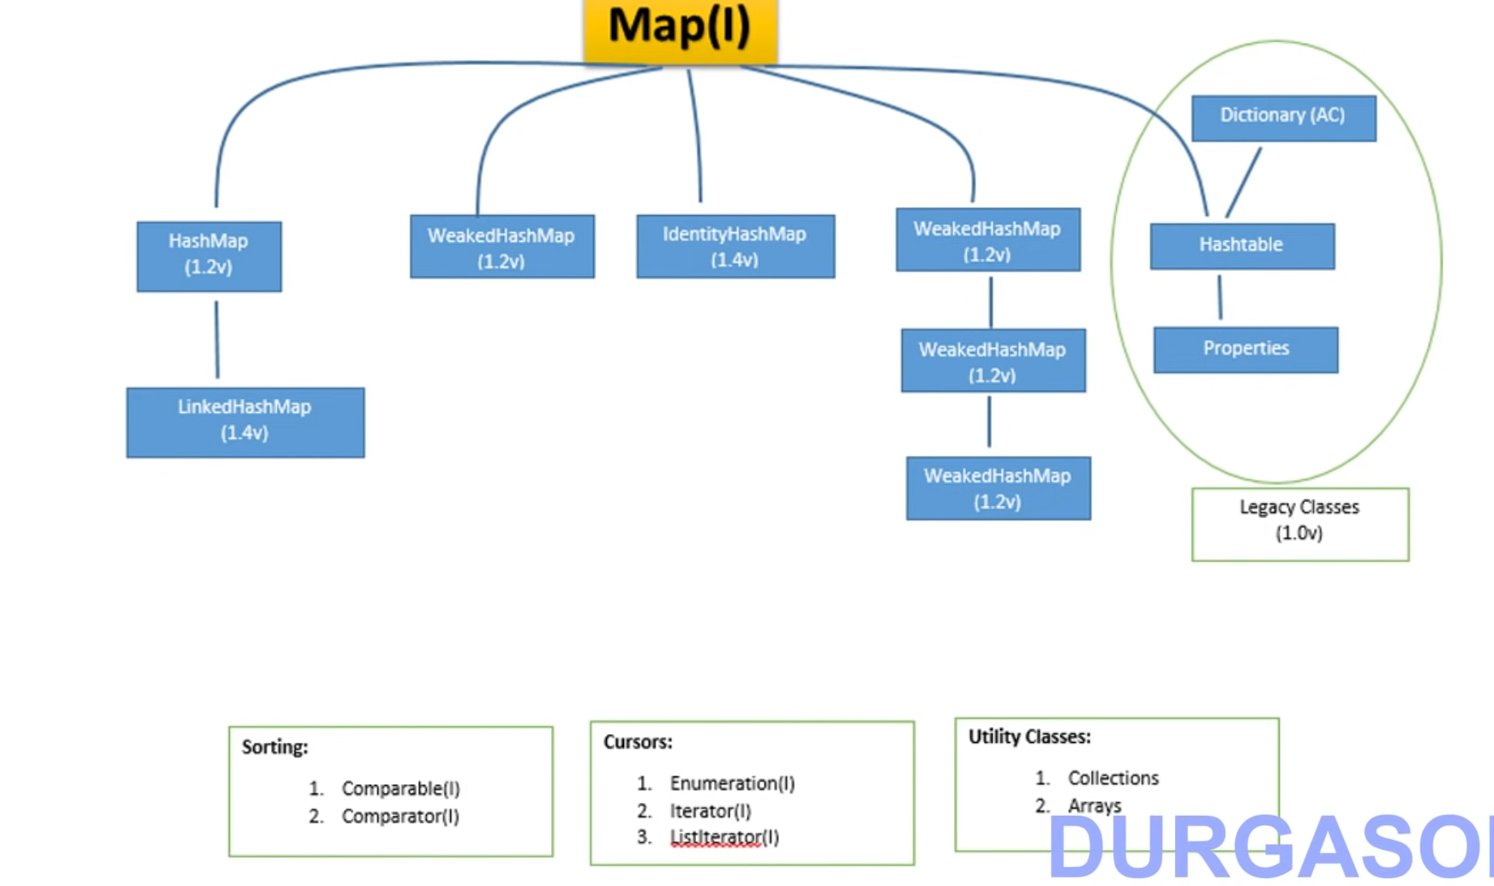

List interface methods:

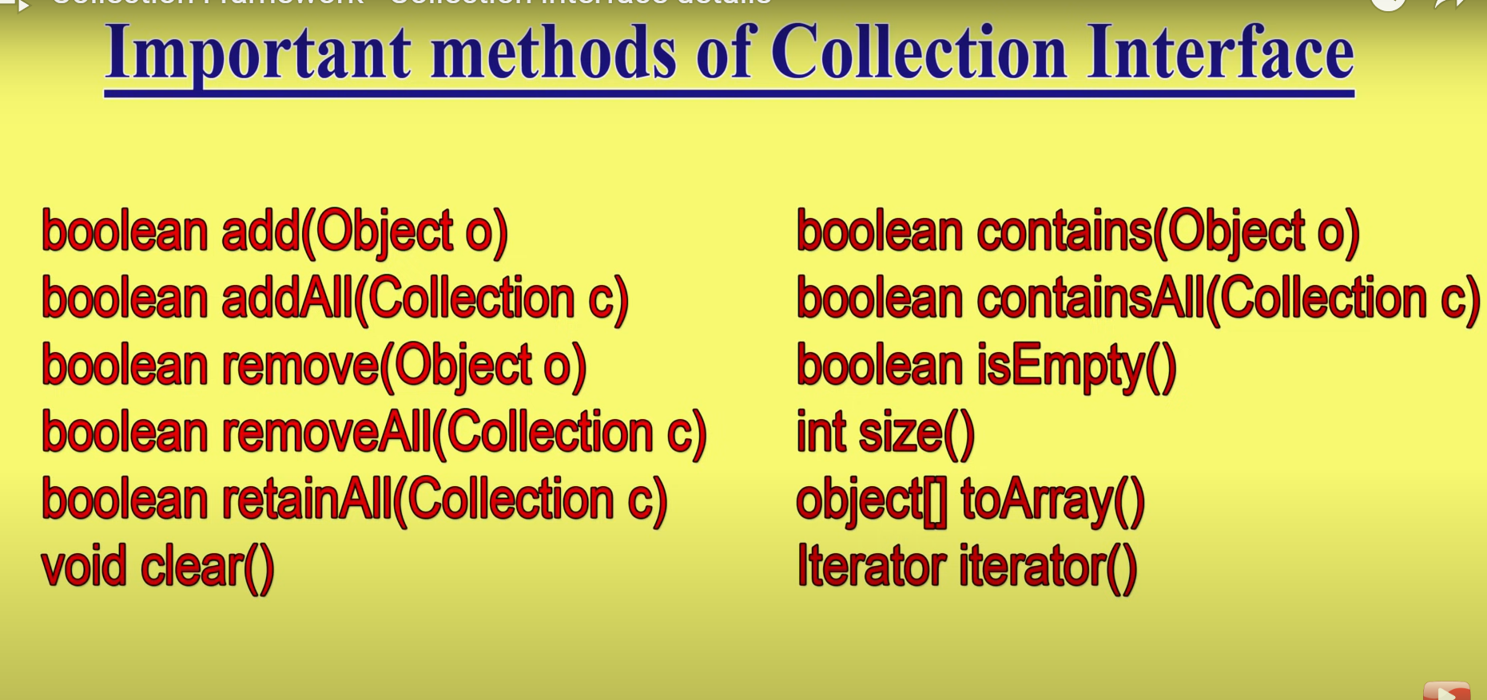

List interface methods:

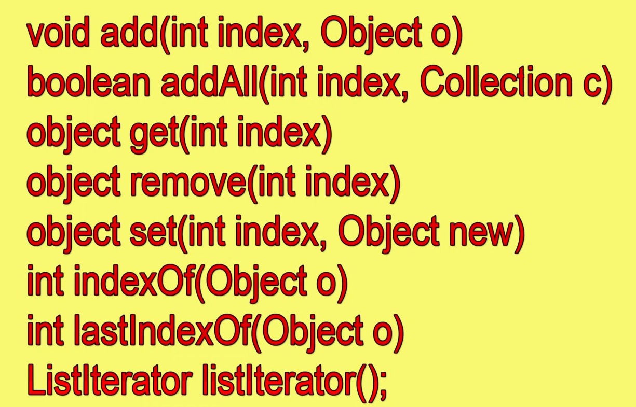

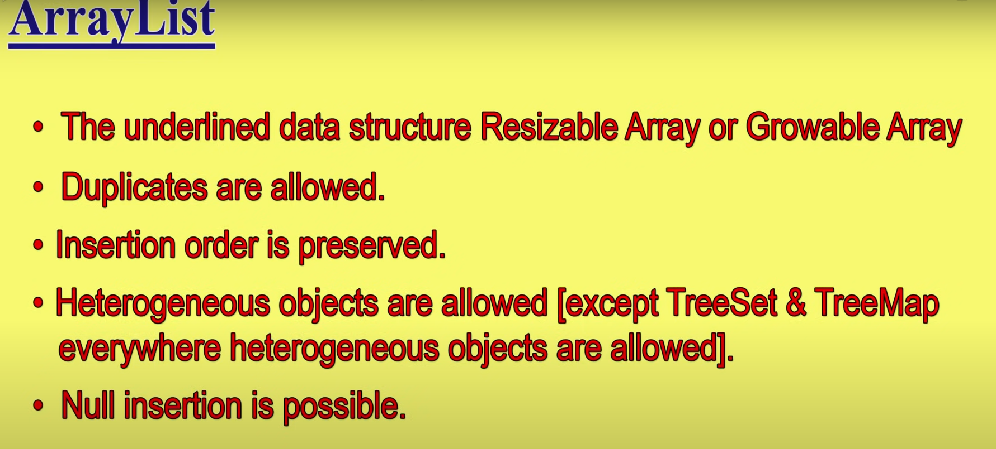

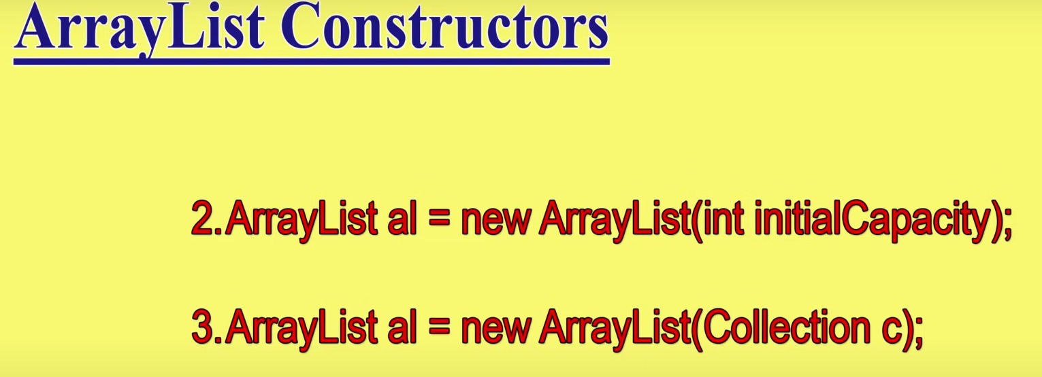

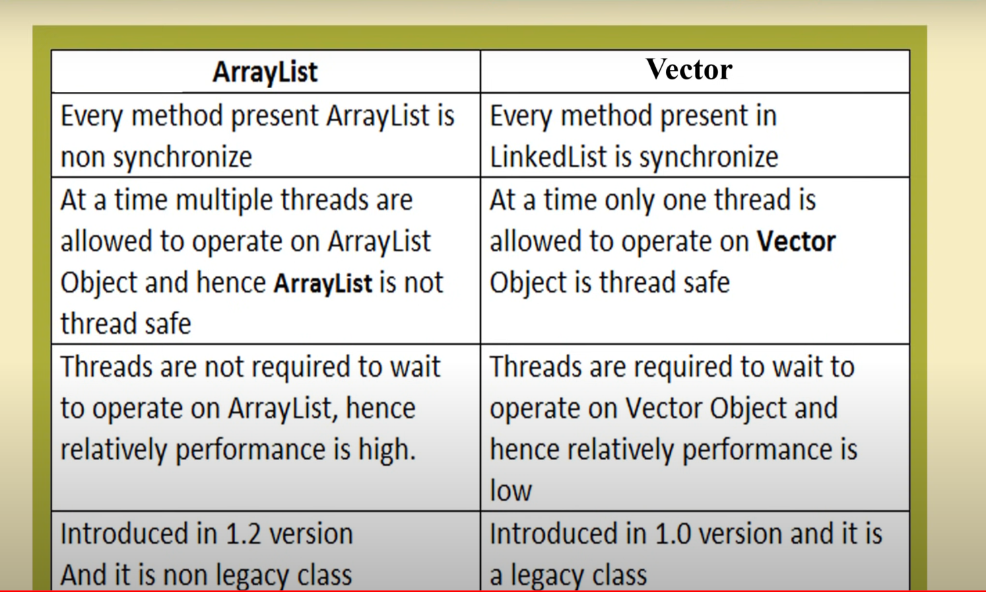

Get Synchronized List & Map

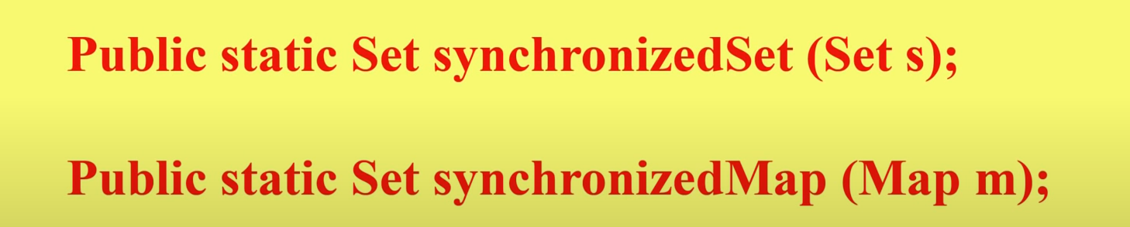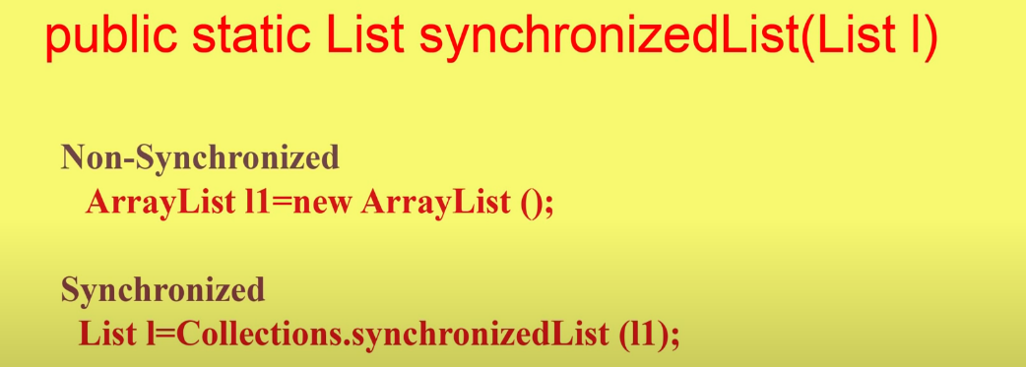

Array List

It is better for RETRIEVAL OPERATIONS because it is index based and it implements a MARKER INTERFACE CALLED RANDOM ACCESS.

Degrades performance when adding & removing elements at particular position because of shift operations.

LinkedList:

Underlying Data structure is Doubly Linked list.

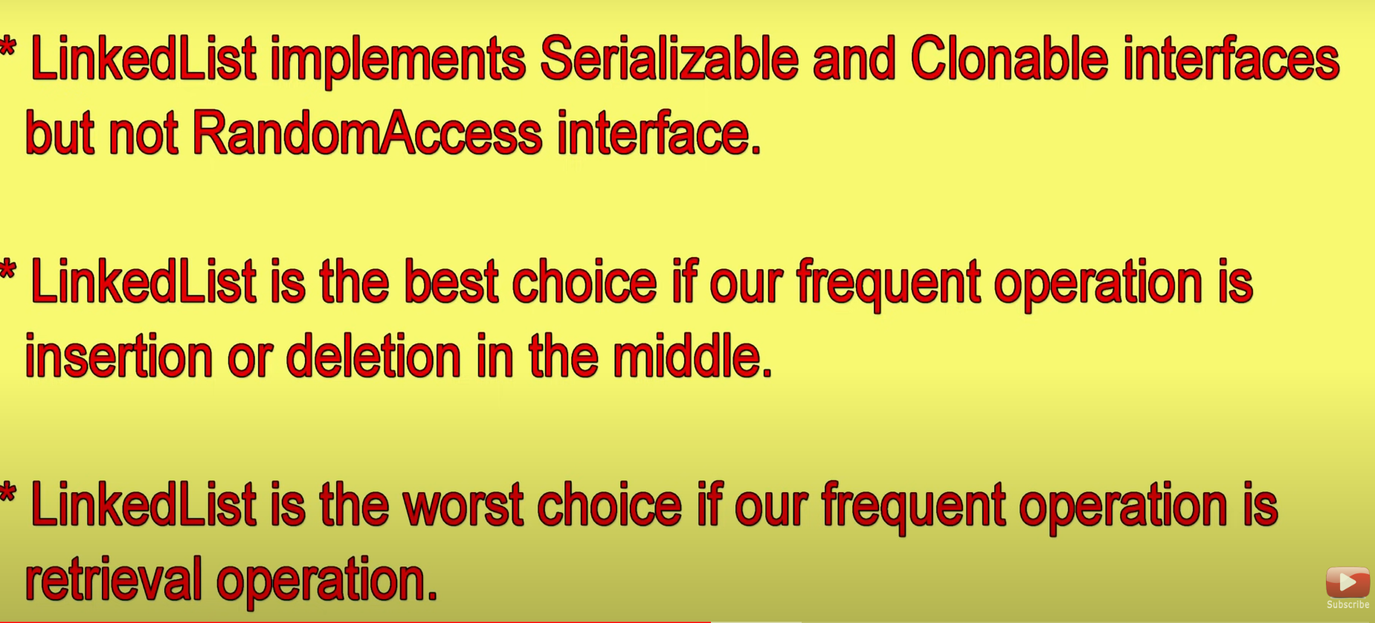

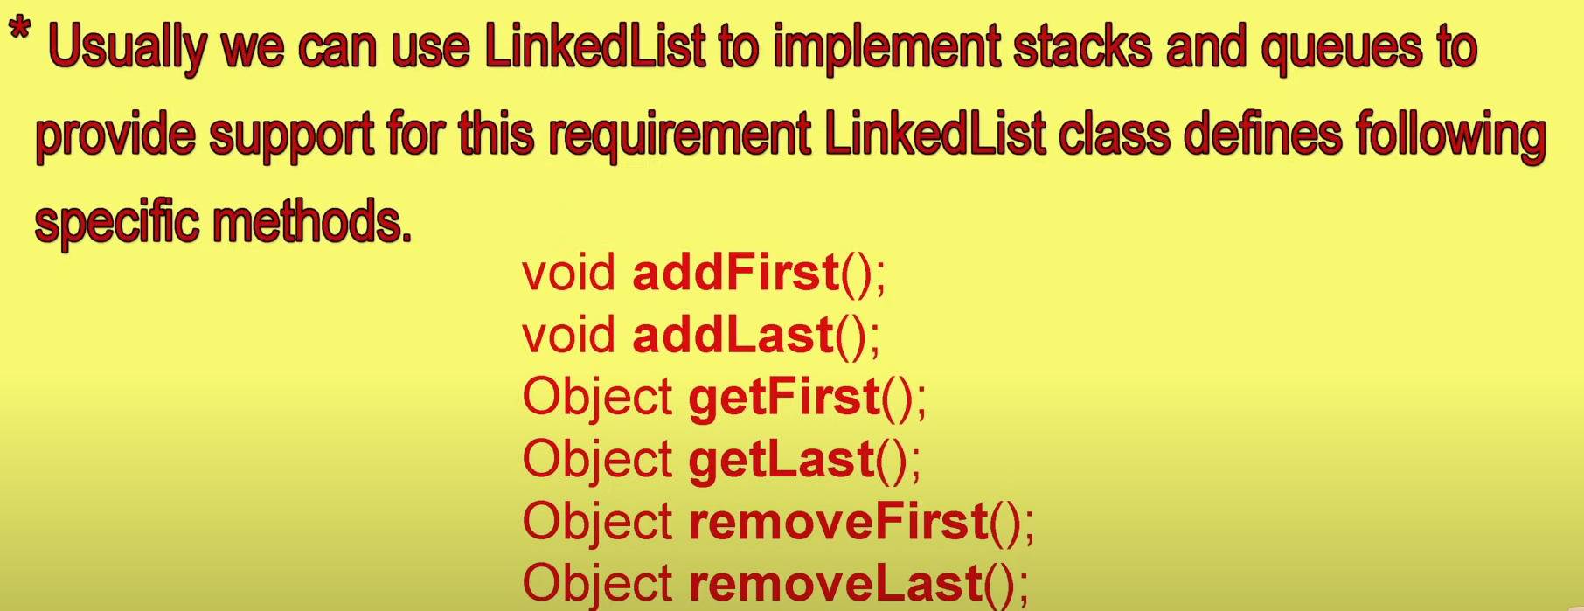

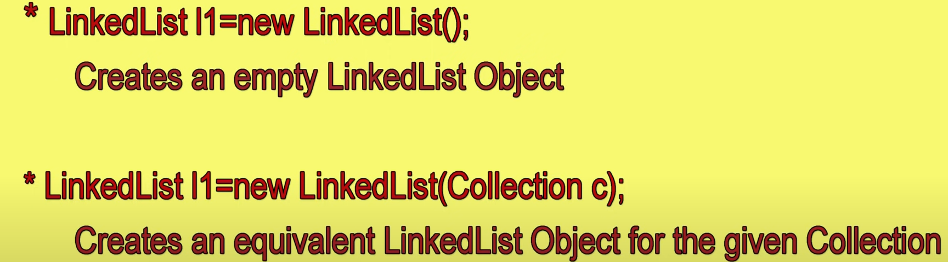 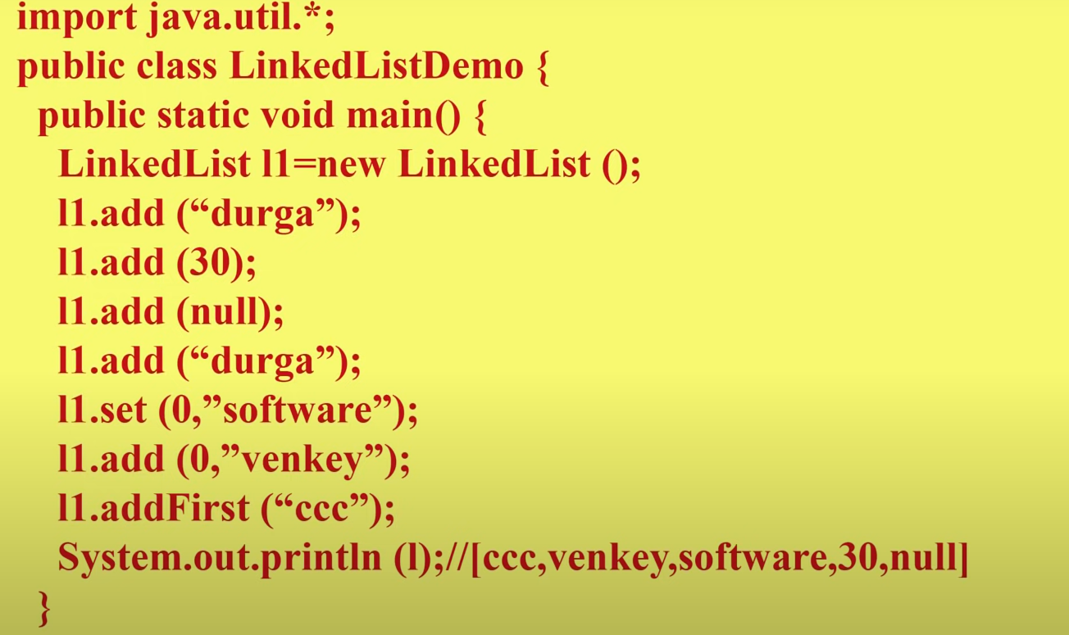

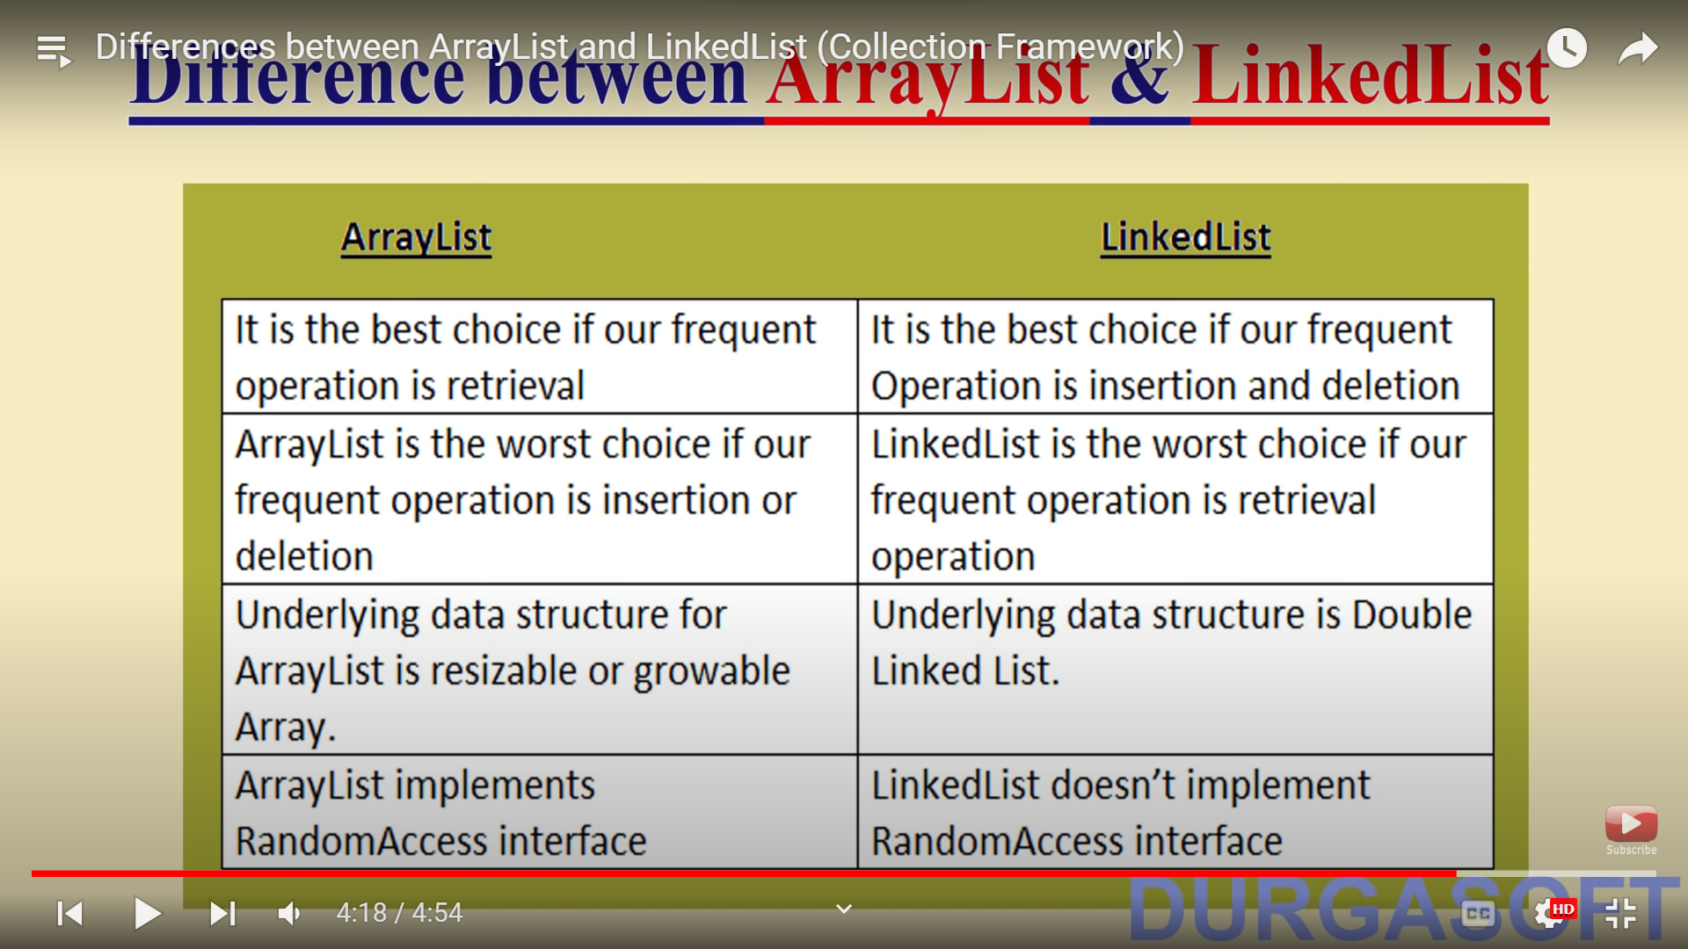

Vector:

ArrayList & Vector are same except synchronization which leads to thread safety.

